Հավասար հայտարար ունեցող կոտորակների համեմատում
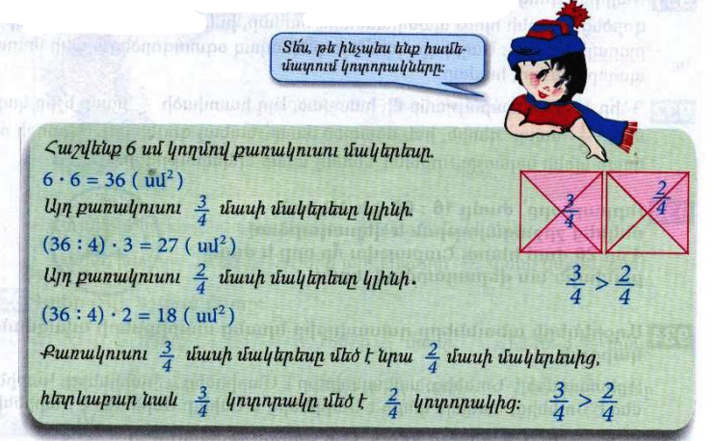
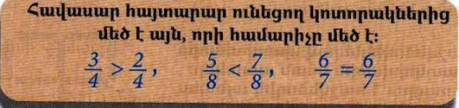
Դասարանական առաջադրանքներ
1․ Համեմատի թվեր
$$\frac{2}{5}<\frac{3}{5}$$

$$\frac{6}{17}> \frac{5}{17}$$

$$\frac{7}{123}= \frac{7}{123}$$

$$\frac{18}{19}= \frac{18}{19}$$
2․ Դասավորի կոտորակները․
Աճման կարգով
$$\frac{3}{17}\frac{4}{17}\frac{6}{17}, \frac{12}{17}, , \frac{15}{17}, \frac{17}{17},$$

3․Համեմատի թվեր
$$\frac{3}{5}մ < \frac{4}{5}մ$$
$$\frac{7}{10}կգ> \frac{4}{10}կգ$$
4․ 4500դր տարողությամբ ջրավազանը ամբողջությամբ լցված էր ջրով։ Այգեպանը այդ ջրի $\frac{2}{3}$ մասը օգտագործեց այգին ջրելու համար։ Քանի՞ լիտր ջուր մնաց ավազանում։
4500:3=1500
5․ Ավտոմեքենան պետք է անցներ 180կմ ճանապարհ։ Ճանապարհի $\frac{2}{3}$ մասն անցնելուց հետո քանի՞ կիլոմետր կմնա նրան դեռ անցնելու։
180:3x2=60x2=120
180-120=60
6․ 1 ծորակից լցվում է 6000լ տարողությամբ ջրավազանի $\frac{1}{4}$ մասը։ Նույն ծորակից որքա՞ն ջուր կլցվի ջրավազանը 2 ժամում։
6000:4=1500
1500x2=3000
7․ Ուրբաթ օրը՝ ժամը 16։00-ին, Աննան մեկնեց շրջագայության և վերադարձավ 4օր 20ժամ հետո։ Շաբաթվա ո՞ր օրը և ժամը քանիսի՞ն նա վերադարձավ տուն։
Չորեքշաբթի 12.00
Տնային առաջադրանքներ
1․ Համեմատի՛ր
$$\frac{14}{18}< \frac{17}{18}$$

$$\frac{3}{7}< \frac{4}{7}$$
$$\frac{11}{28}> \frac{9}{28}$$

$$\frac{24}{143}> \frac{21}{143}$$

2․ Դասավորի՛ր կոտորակները․
Նվազման կարգով
$$\frac{35}{35}\frac{31}{35}\frac{22}{35}\frac{19}{35} \frac{17}{35} \frac{4}{35}$$
3․Համեմատի՛ր
$$\frac{3}{20}լ < \frac{6}{20}լ$$

$$\frac{2}{15}ժ< \frac{4}{15}ժ$$

4․ 4500լ տարողությամբ ջրավազանը ամբողջությամբ լցված էր ջրով։ Այգեպանը այդ ջրի $\frac{2}{3}$ մասը օգտագործեց այգին ջրելու համար։ Քանի՞ լիտր ջուր օգտագործեց այգեպանը այգին ջրելու համար։
1500X2=3000
5․ Ջրավազանում կար 8000լ ջուր։ Այգին ջրելու համար պապին օգտագործեց այդ ջրի երեք քառորդ մասը։ Որքա՞ն ջուր մնաց ջրավազանում։
8000:4=2000
6․ Մայրիկը գնեց 12կգ շաքարավազ։ Նա այդ շաքարավազի $\frac{1}{3}$ մասն օգտագործեց ծիրաանի հյութ պատրաստելու համար, իսկ մնացած մասը՝ ելակի մուրաբայի համար։ Մայրիկը որքա՞ն շաքարավազ օգտագործեց ելակի մուրաբա պատրաստելու համար։ 12:3=4
7․ Երկու թվերի գումարը 650 է, իսկ տարբերությունը՝ 0։ Որո՞նք են այդ թվերը։ 325

